PRESS INFORMATION
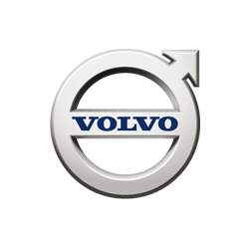

Volvo CE appoints new Illinois dealer

Alta Equipment Company, an established Volvo Construction Equipment dealer in the Midwest, will expand its support to customers in central and northern Illinois.
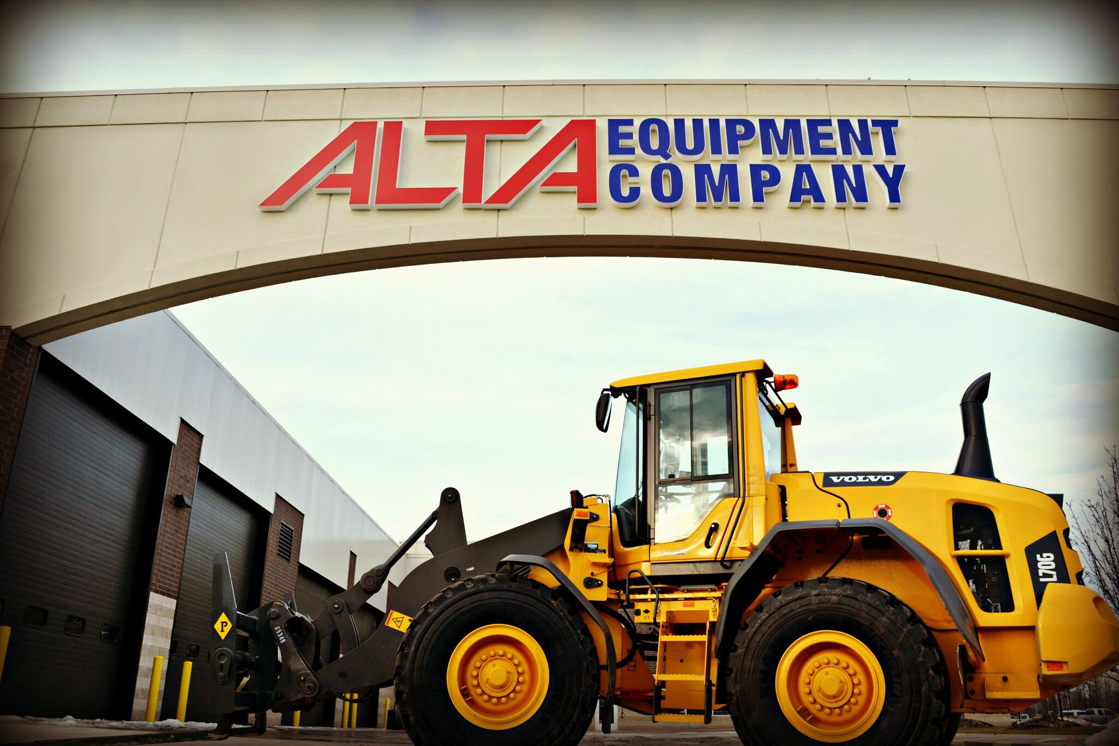
Volvo Construction Equipment (Volvo CE) recently appointed Alta Equipment Company as its authorized dealer in central and northern Illinois. Alta Equipment Company will start providing Volvo CE parts and services immediately. The company will open new locations in the region specifically designed for the needs of the construction equipment market.

“At Volvo CE, we partner only with dealers who are dedicated to customers’ success. Alta Equipment continues to be a great partner offering products and service that meet and exceed customers’ needs,” said Stephen Roy, president, Sales Region Americas, Volvo CE. “Together with Alta, we will continue to help customers maximize product value throughout their lifecycle and unlock the full potentials of Volvo CE equipment.”

Alta Equipment Company has represented Volvo CE since 2009 in Michigan, carrying all of Volvo CE’s product lines as well as some allied products that complement the Volvo CE offerings.

“We are excited about our expansion into Illinois because it is another opportunity for Alta Equipment Company to build upon its mission of being a total solution for the construction and industrial markets and to continue to invest in the best products and people,” said Rob Chiles, president of the construction equipment division of Alta Equipment Company.

Alta has also been among the fastest growing Volvo CE dealers in the U.S. Now with the capability in central and northern Illinois, Alta is positioned with a comprehensive product and service offering aimed at developing enduring customer relationships, according to Ryan Greenawalt, president of Alta Equipment Company.

“Alta is proud to represent Volvo as our flagship brand because we are serious about delivering the best value proposition in the industry,” said Greenawalt. “We are committed to representing only world-class products and backing them with exceptional support.”

END.
September 2017

For more information, please contact:
Dave Foster Chi-an Chang
Vice President SE10
Marketing and Corporate Communications Americas
Sales Region Americas Tel: 312 401 2404
Volvo Construction Equipment Email: chi-an.chang@se10.com
Tel: 717 530 6169
Email: dave.foster@volvo.com

Click and follow us:
Visit http://www.thenewsmarket.com/volvogroup to access broadcast-standard video from the Volvo Group. You can preview and request video material as MPEG2 files or on Beta SP tapes. Registration and video material are free for the media.
The Volvo Group is one of the world's leading manufacturers of trucks, buses, construction equipment, and marine and industrial engines. The Group also provides complete solutions for financing and service. The Volvo Group, with its headquarters in Gothenburg, employs about 95,000 people, has production facilities in 18 countries and sells its products in more than 190 markets. In 2016 the Volvo Group's net sales amounted to about SEK 302 billion (EUR 31,9 billion). The Volvo Group is a publicly held company. Volvo shares are listed on Nasdaq Stockholm. For more information, please visit www.volvogroup.com or www.volvogroup.mobi if you are using your mobile phone.

